ONLINE PARKING/GOLF CART RENTAL INSTRUCTIONS FOR NEW HALLETT REGISTRATION SYSTEM ----
HALLETT EVENTS/TEST DAYS - COMMA, KART, NASA, LEMONS, HONDA, and MIATAS

1. Please click link below to login or setup your new HMRC profile and ensure you continue to receive our emails!
https://hallett.alphatiming.co.uk/register/events

2. Click "Book Reserved Parkings" button on right side if NOT registering for HMRC test day. OR click "Find Events" and find clink "Book Paddock Spaces" link on test day event to book parking at same time as you register for event/test day.
HALLETT EVENTS/TEST DAYS - COMMA, KART, NASA, LEMONS, HONDA, and MIATAS
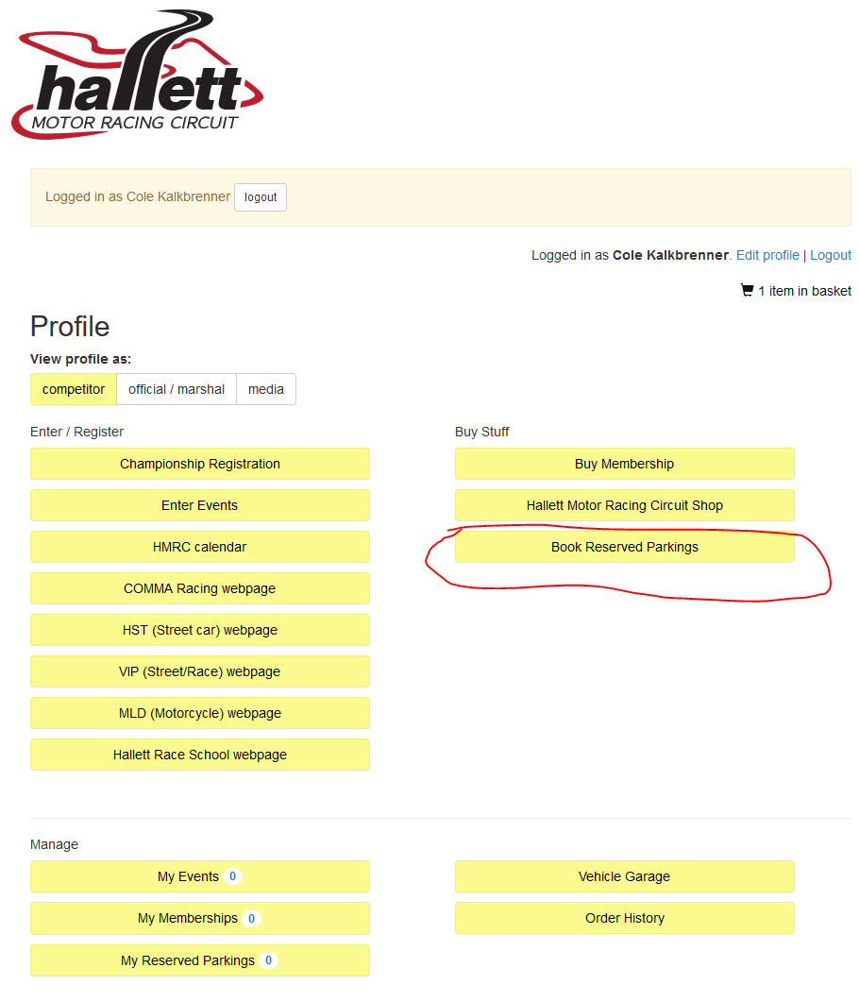
OR click link on test day event below.
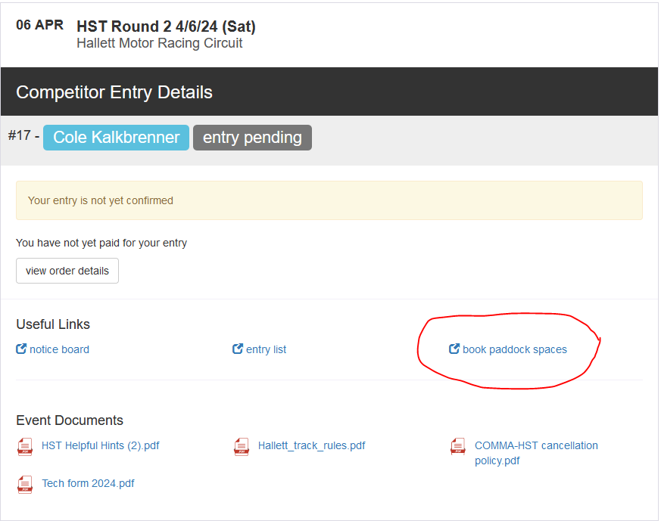

3. Click on "Single Event Paddock Spaces".
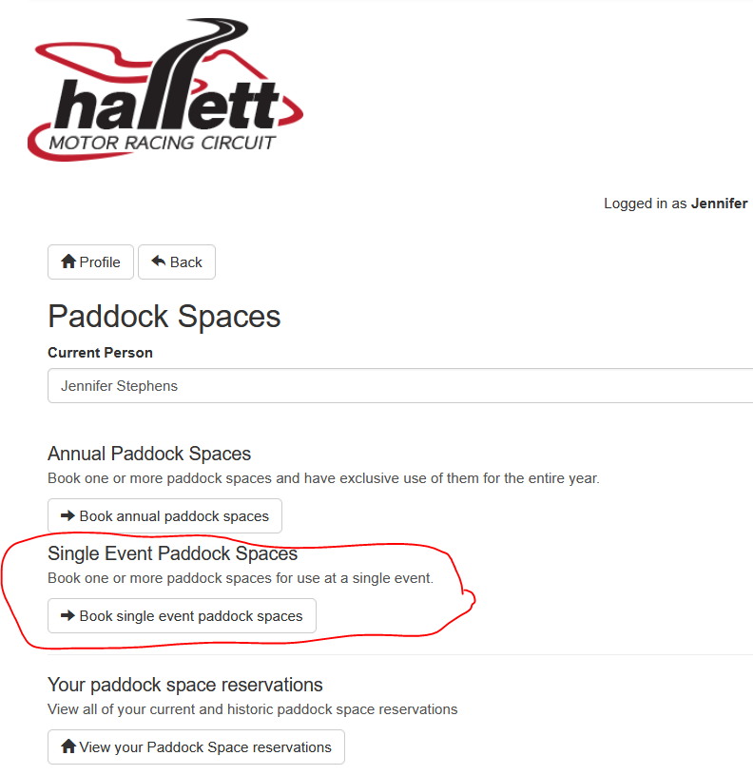
4. Click on "Select Paddock Space" for event of your choice on right, then use the dropdown below the map image to see what spots are left available to reserve to complete purchase. If none available, you can call office to get added to waitlist in case of cancellation.
