ONLINE PARKING/GOLF CART RENTAL INSTRUCTIONS FOR NEW HALLETT REGISTRATION SYSTEM ----
CMRA, CVAR, APEX, GOLD RUSH OFFROAD, and FORD MEET (RVs ONLY)

1. Please click link below to login or setup your new HMRC profile and ensure you continue to receive our emails!
https://hallett.alphatiming.co.uk/register/events

2. Click "Book Reserved Parkings" button on right side for NON-Hallett event parking. For Hallett events, clink "Book Paddock Spaces" link on event to book parking at same time as you register for event/test day.
NON-HALLETT EVENTS - CMRA, CVAR, APEX, GOLD RUSH OFFROAD, and FORD MEET (RVs ONLY)
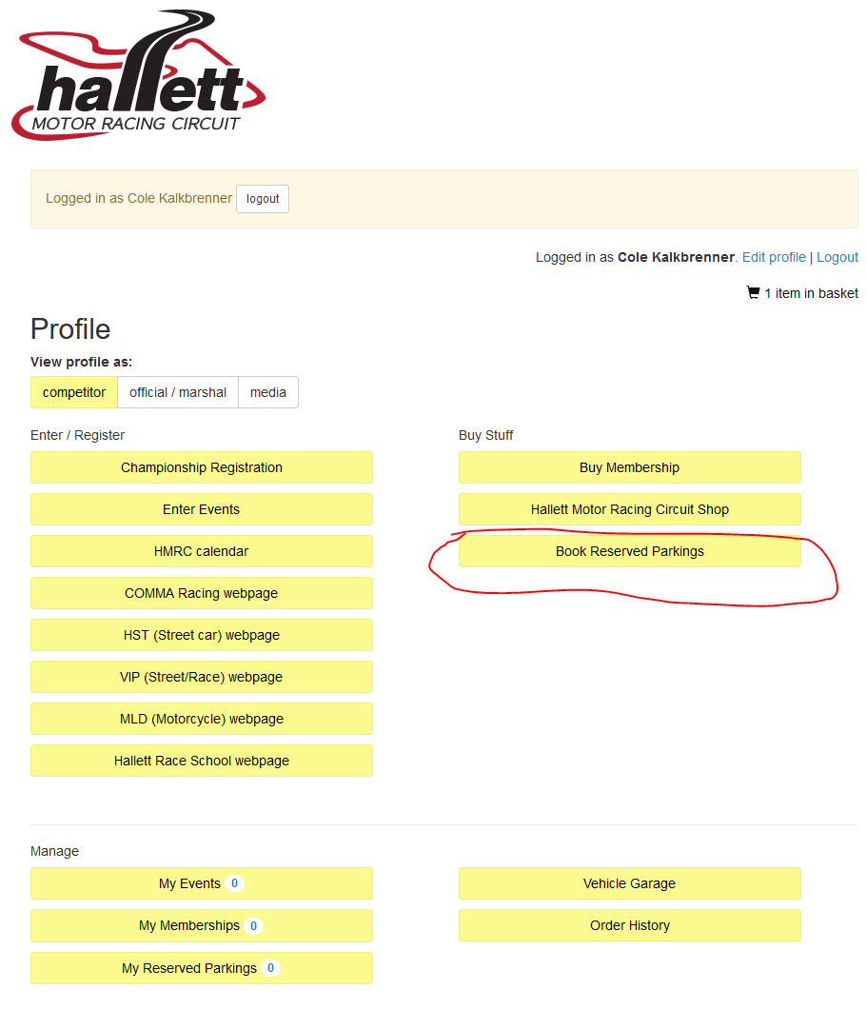

3. Click on "Book Annual Paddock Spaces".
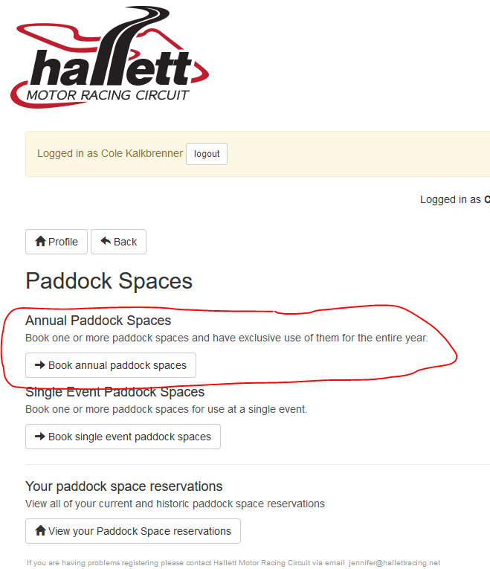

4. Click on "Select Paddock Space" for event of your choice on right, then use the dropdown below the map image to see what spots are left available to reserve to complete purchase. If none available, you can call office to get added to waitlist in case of cancellation. If none available, you can call office to get added to waitlist in case of cancellation.
